Dynamic Time Warping Application – Diagnosis of Reactor Systems
Module 4 – Portfolio Milestone

Andrew J. Cunningham
Colorado State University Global Campus
CSC506 – Design and Analysis of Algorithms
Dr. Brian Holbert
07 April 2025

Overview Summary
For the full summary please reference Module 2, portfolio milestone, I’ll just cover the basics here.
The objective of this portfolio is to implement Dynamic Time Warping (DTW) and backtracking to detect nuclear reactor core failure criteria based on analyzing ex-neutron signal fluctuations gathered by sensors positioned around a theoretical reactor core support barrel. I’ll be following a study conducted by Inha University, Incheon, in the Republic of Korea (Jeong et al., 2024). This project is highly technical in nature, so many simplifications will be made to stress algorithm development and implementation. Data will be simplified and simulated using best-practices, and results will be developed and assessed following the example provided in the study.

Simulating Input Data
Selecting the right algorithm to simulate input data remains to be the most challenging aspect during early planning for this project. Little data is publicly available, and I have very little experience simulating data with python.
Learning the basics of numpy to generate sinusoidal data was my first task. At a high level, I’ll need to understand the following functions, utilizing numpy documentation (NumPy quickstart 2025):
time = np.linspace(start, stop, step) # used to generate a list of numbers evenly spaced over an interval
amplitude = np.sin(variable * time) # used to simulate the amplitude of the sin wave
np.random.normal() # to input normal noise
np.roll(data, magnitude) # used to phase shift the frequency data, which doesn't respond well in testing, but available

Next up I studied the basics of generating sin waves in python. I care mostly about manipulating the amplitude of the wave over a time range (Codesansar , 2025). Putting this all together, I was able to develop a test sine-wave generator.

import numpy as np
import matplotlib.pyplot as plt

def gen_simple_sin(frequency, rate, amplitude):
duration = 1 / frequency # creates one period
t = np.linspace(0, duration, int(rate * duration))
sin_data = 5 * np.sin(2 * np.pi * frequency * t)

return sin_data

frequency = 1
sample_rate = 1000
amplitude = 2

plt.plot(gen_simple_sin(frequency, sample_rate, amplitude))
plt.show()

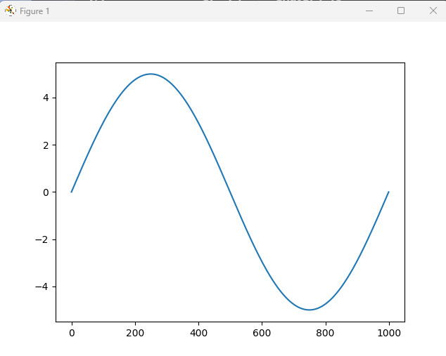

Sin waves, itself, is not what’s going to be at the root of the analysis, for that I need to learn more about Fast Fourier Transforms to get the amplitude data. I need to convert frequency-time data to frequency magnitude for application of DTW. Fortunately, FFT is built into numpy.

References
Jeong, H., Kim, J., Jung, D., & Kwon, J. (2024, December 9). Deep-Learning and Dynamic Time Warping-Based Approaches for the Diagnosis of Reactor Systems. Sensors Journal. https://www.mdpi.com/1424-8220/24/23/7865
NumPy quickstart. NumPy quickstart - NumPy v2.2 Manual. (2025). https://numpy.org/doc/stable/user/quickstart.html
Python program to plot sine function using Numpy & Matplotlib. Codesansar. (2025). https://www.codesansar.com/python-programming-examples/sine-wave-using-numpy-and-matplotlib.htm

